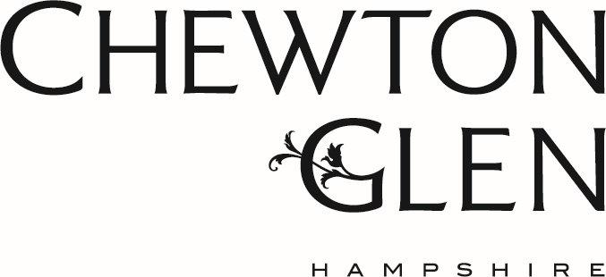

Chewton Glen is a five-star privately-owned luxury country house hotel situated on the edge of the New Forest, just minutes from the sea. Boasting a world-class spa, luxurious accommodation and modern meeting facilities, Chewton Glen is the perfect destination for meetings, retreats, corporate hospitality and top-level incentives.

The hotel’s Vetiver restaurant offers a number of elegant interconnecting rooms of varying sizes and styles, including The Conservatory, Summer House, The Oak End and our “Sommelier’s Table” the Wine Room, allowing unparalleled flexibility for corporate groups.
The main hotel has 58 luxurious, individually-designed suites and bedrooms situated in 130 acres of immaculately maintained woodland and parkland. Additionally Chewton Glen boasts of 12 fabulous Treehouse Suites set high amongst a woodland canopy. The hotel also has various sizes and styles of function space fitted with the latest technology combining efficiency and ease of use with the elegance and unparalleled luxury that are the hotel’s trademarks.

Chewton Glen is only two hours away from central London (less than two hours by rail on the main line from Waterloo) and only 20 miles from Southampton Airport which has regular flights from many cities within the UK and the rest of Europe. There is ample space for a variety of teambuilding activities on the hotel’s sweeping grounds and guests can also enjoy a wide range of unique land and water-based activities in the New Forest and on the Solent.

Chewton Glen received a Silver Award as ‘Best UK Hotel’ in the 2013, 2014 & 2015 M&IT Industry Awards

NEW in autumn 2016: James Martin Cooking School!

