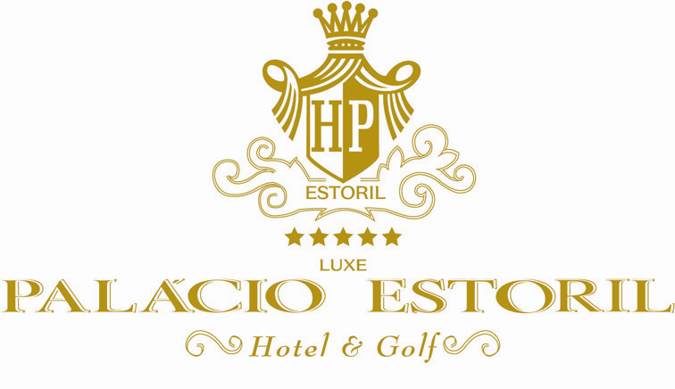

Estoril and the Hotel Palácio
One man’s dream come true

The Hotel Palácio, standing in majestic splendour facing acres of manicured gardens that stretch to the Atlantic Ocean, is the result of one man’s dream and perseverance. Fausto Figueiredo saw in Estoril, Portugal, the possibility to create a jewel by the sea.

Before the First World War, Fausto Figueiredo envisioned hundreds of people strolling through the marble corridors and down mosaic sidewalks to the ocean as he gazed out over scrub, pines and sandy hills. Without the determination of that man, Estoril would still be just that.

However, it was to be 1930 – the height of the American depression – before those dreams materialised. By then, the Hotel Palácio had been built, as had the Casino and the acres of garden. And, at the time when the World was wondering about the availability of money to support a luxury resort, the Hotel Palácio threw open its doors. Pageboys were standing at attention in immaculate uniforms, the reception desk had been polished to a high gloss, and magnificent menus had been planned for the dining room, lighted with massive crystal chandeliers. Where were the guests? Had it been a dream that could not materialise in that troubled time?

Miraculously, the first guest drove up – The Crown Prince of Japan and his bride on their honeymoon. The next guest to register was the French Ambassador. And, from that first moment, those marble corridors of the Palácio Hotel enclosed a way of life, which was to become the most elegant in Europe, always known for elegance. The Hotel Palácio achieved the ultimate. It was known as “home” for visiting royalty when the court would go on a vacation.

The heady success continued throughout the thirties and when rumbles of trouble and war were being heard throughout Europe, people started to wend their way south to a haven they had known in happier times. As each country was invaded, royal families moved to Estoril to find a sanctuary from the holocaust, which was destroying lives and homes. Many of the royal families used the Hotel as their temporary home while villas were being built, or purchased, so they could set up a way of life in spit of the great losses they had suffered. Several of the families have stayed on. Ex-king Umberto of Italy was one of the leaders, as in Don Juan de Bourbon, the father of the King of Spain.
The war took its toll, however, in spite of Portugal’s maintaining neutrality. The Hotel Palácio, and the Casino, which had also been built by Fausto Figueiredo, became the centre of activity for both the allies and the enemy. If walls could talk, the room you sleep in today could tell a story of intrigue and espionage. In spite of all this, the Hotel Palácio remained aloof in its quite elegance and although people were sleeping in halls – anywhere they could find that might provide a bit of privacy – the woman still dressed for dinner and jewels glittered in the reflected light of the shining crystal prisms. At times, when people had escaped destruction with a case of jewels and the clothes on their back, diamonds and rubies and gold were accepted instead of money.

At the end of World War II, many people returned to their countries, but the Hotel Palácio remained as a haven in their memories. Travel started again and they came back to visit. Because of the royal families in residence, the Hotel continued to be headquarters for royal and titled visitors. It is the same today. When the Princess of Spain was married, the bridal dinner was given in the main dining room. The Italian Princess held her reception in the Hotel. People from all over the world sought out reservations and the Hotel Palácio continued its reign as one of the most elegant and important hotels in Europe.

In 1951, the man who had envisioned this playground of the western world died. Fausto Figueiredo will never be forgotten. Estoril and the Hotel Palácio stand as a tribute to his memory.

